Da Xin

CSCE 489 Visualization Checkpoint Part 2:

For the visualization of my data I had initially chosen to use google’s geochart to chart all of the players. However I immediately encountered huge problems.

1. The data was too big. I have over 30 thousand points and with javascript it would have taken an incredibly long time to plot every single one. So then I clustered all the folks in the same town together hoping to make it faster. Well it did but it was still too slow. There ended up being 4957 cities and to plot that takes forever. (screen shot of the plotting about 5% complete roughly 3 minutes) Even if the plotting would be relatively fast, the data points still only show the town as a whole, not each individual recruit.

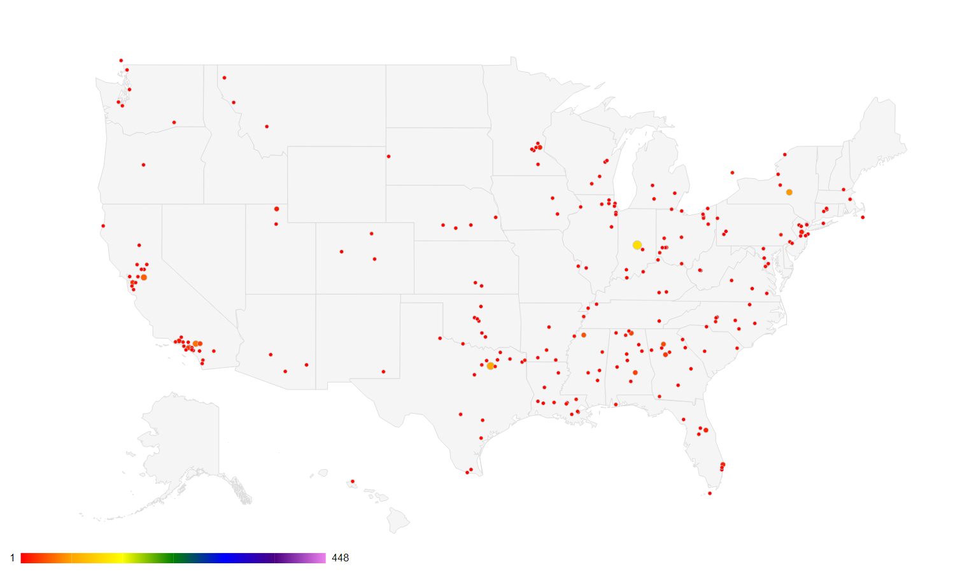

1. Next I tried City which solved the problem of computation time, but lost many of the values and thus the point of the entire project, which is to make inference from the data. With out being able to interact with the data the data becomes pointless so clustering in to just states is some what point less.

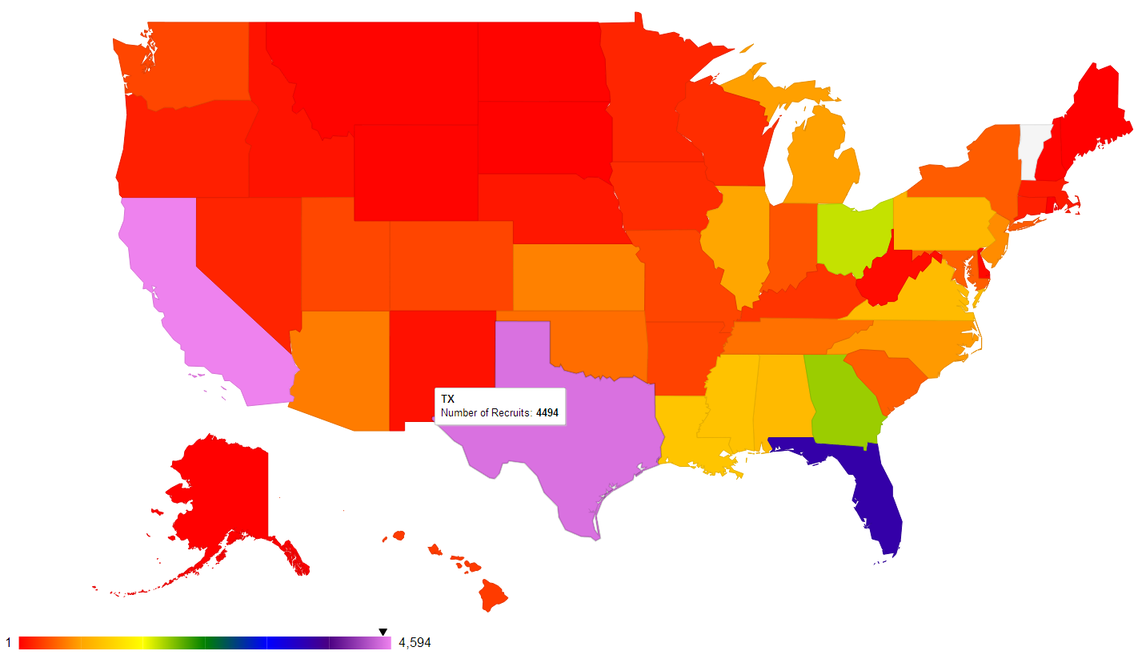

Just when I was about to run out of ideas Google showed me one of its developmental products known as google fusion table. What an awesome tool. I uploaded my data to the table and then google senses that the location column contains locations and uses the google maps api to plot them for you on the map. (The plotting takes a very long time but is fine because, once complete you don’t need to redo it, I.E. indexing time is long but none during processing). The filters are also functional so I’ve been able to change the year, height, weight, 40 speed, etc. which is really awesome. Lastly, this tool allows scrolling which means I can plot the whole world. There are recruits from Germany, Canada, etc. so its cool to see the few kids from out of the country. This is highly rare because the number of letter of intents are very tight so not many programs takes a change on a kid over sees that they’ve never seen in person. It’s a lot less uncommon for foreign kids to come and try out as a walk on or at division two and then earn a scholarship.

Now that the plotting portion is complete, I must look at the data and draw the conclusions. I will study different trends and see if there’s anything useful I can gather from the data.